Timestep in Combined Finite and Discrete Element Method

Author: Li Wanrun

Date: 2023/03/28

1. Introduction

Timestep is an important factor in FDEM simulation since the involved explicit temporal integration. A reasonable timestep not only can ensure the stability and accuracy of numerical formulation, but also can significantly improve computational efficiency. However, the timestep in FDEM is influenced by many factors (such as mesh size, material properties and damping coefficient) and it is not trivial to find the optimal timestep size. It is even worse when the multi-physical field problems are involved. Therefore, it is significantly important to estimate the optimal timestep size before the simulation begins. In this manual, two methods of a priori estimation and a posterior estimation are introduced and the prior estimation is recommended due to its convenience.

1. Timestep Selection

In the mechanical analysis, the second-order ordinary differential equations with respect to time are obtained by spatial discretization. Then, the central difference formulation is employed in temporal domain to update nodal velocity and nodal coordinates. Due to the underlying independence between nodal balance equations, the analysis of stability is only considered in one equation.

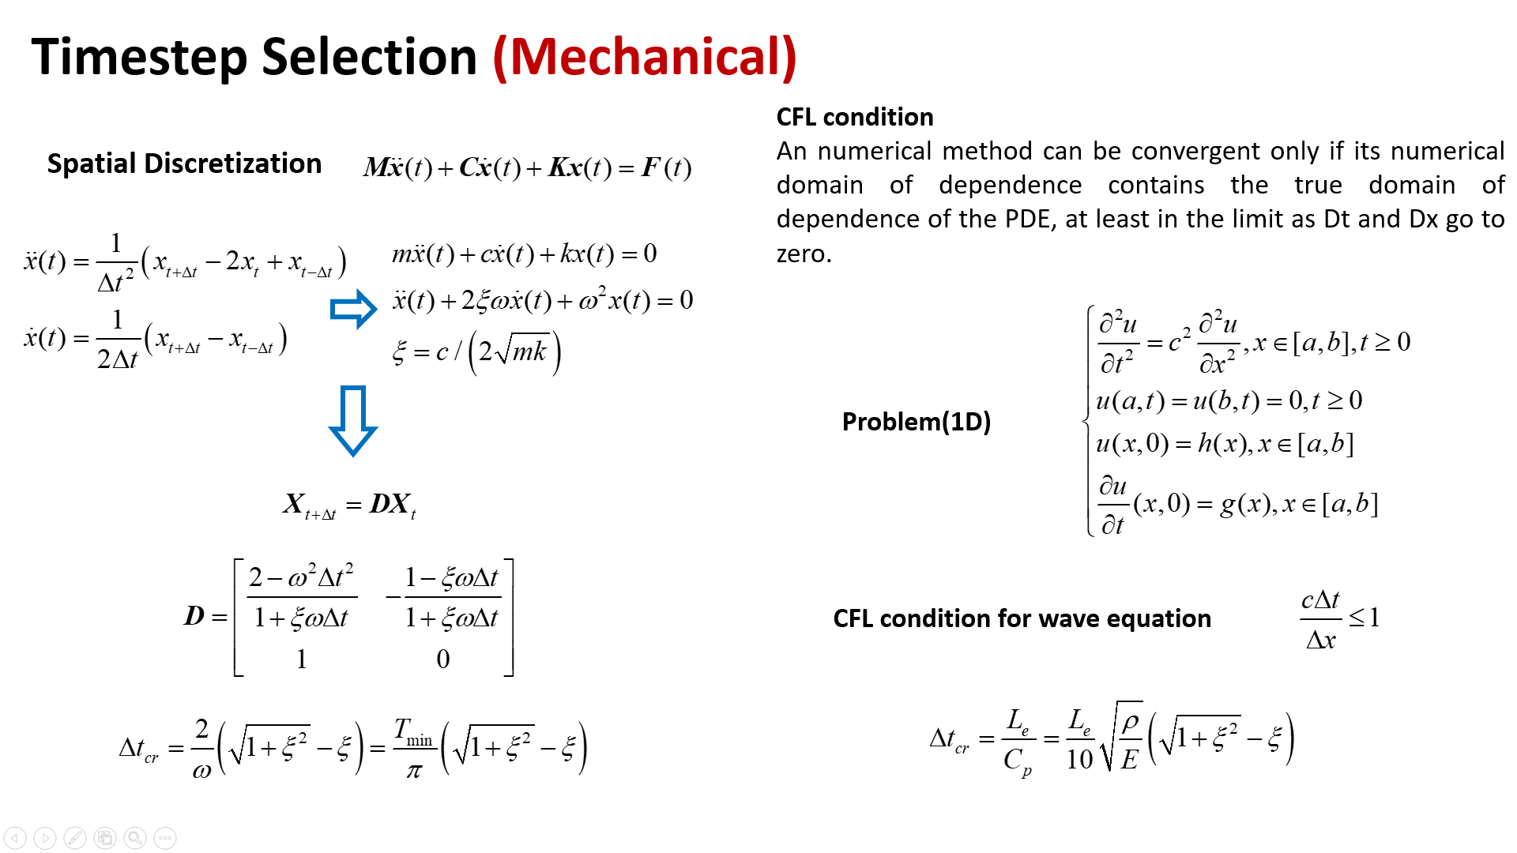

Fig.1 The mathematical principle of numerical stability for hyperbolic PDE.

The analysis of stability requires that the rounding error should not be magnified in numerical simulation (Fig.1), that is, the spectral radius of the amplification matrix should not larger that 1.0. This method is based on the nodal quantity and has the ability to derive an accurate stable timestep, but more extra calculation is needed before numerical analysis. An alternative to the problem of stable timestep is to meet the CFL condition, which can be physically interpreted as the time spent when the elastic wave propagates through the minimum mesh size. This priori estimation method could imply an approximate stable timestep but only with the input information. When it comes to the multi-physical field problems, the above procedure is also applicable and effective (Fig.2).

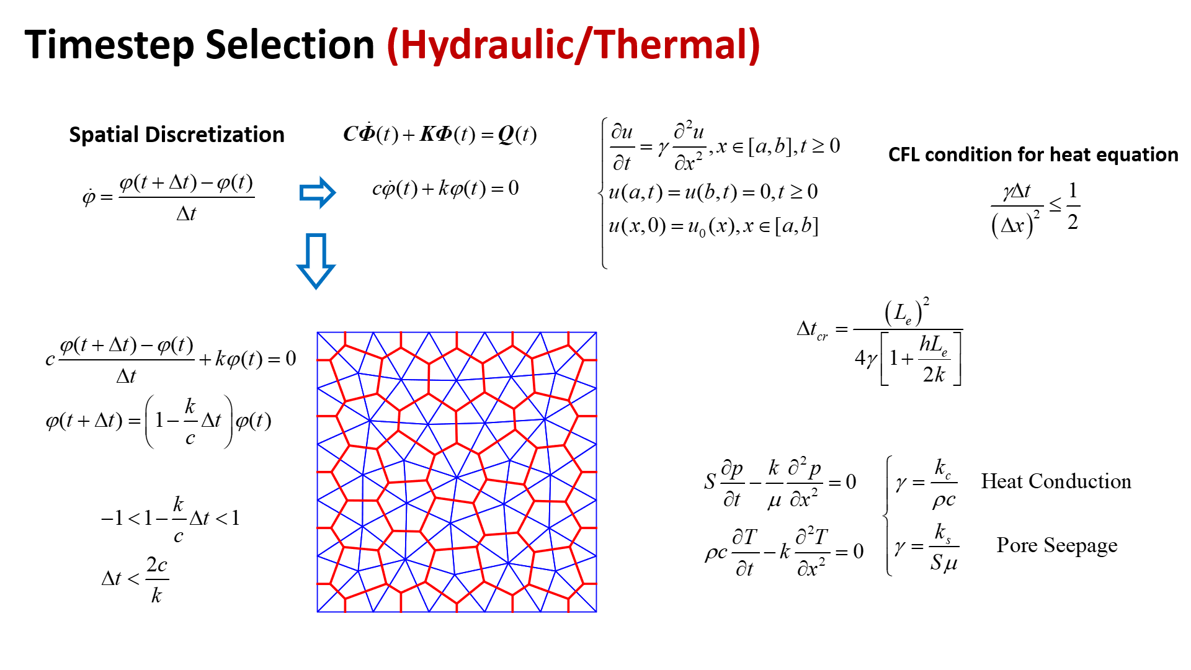

Fig.2 The mathematical principle of numerical stability for parabolic PDE.